**AABS Test Plan**

This document contains the detailed listing of the test cases for Ashram Accommodation Booking System(AABS).

The basic operations present in the software are:

1. Register or Sign in for User/admin.
2. Check Room Availability.
3. Booking Room.
4. Update Profile.
5. View current bookings.
6. Cancel Booking.
7. Booking room for special guests by admin.
8. Remember Password.
9. Add/delete room.
10. Remove users
11. Update user proof
12. Checkin user
13. Block/Unblock rooms
14. Generate Admin registration Link

|  |  |  |  |
| --- | --- | --- | --- |
| Test Case ID | Purpose | Steps | Expected Result |
| 1 | Register User | * Click on the register user button * Fill in the registration form with wrong email format /mismatch in password and confirm password and press the submit button. | * If the details entered are valid redirect to mobile number verification page(OTP). * If the password entered mismatch or the email id is not in correct format submit button doesn’t get activated and prompts the user with appropriate errors. * Error if password length is less than 8 characters * Username can have alphabet and numeric values . |
| 2 | Update Profile | * Click on update profile button * Change the name/email/password * Click on the save button | * The changes will get updated in the database. |
| 3 | Check room Availability | * Enter the check-in date * Enter the check-out date | * Displays the availability on the given dates. |
| 4 | View bookings | * Click on bookings. | * Displays already made bookings. * For admin it displays offline bookings. |
| 5 | Cancel Booking | * Open current bookings * Select a specific booking to be cancelled. | * Booking gets cancelled. |
| 6. | Generate admin registration Link | * Login as admin * Click on generate link | * A link is generated using which the user user has to register to get admin powers. |
| 7. | Remember Me | * Select remember me option while logging in | * Credentials will auto fill from next login. |
| 8. | Add/delete Room | * Login as admin * Fill in room details * Add room * Else select a room to delete | * Room gets updated in the database. |
| 9. | Remove Users | * Login as admin * Select user to be removed * Remove users | * Users will get removed from database. |
| 10. | Update user proof | * Update the Id proof for a booking. | * New Id proof is updated in the database |
| 11. | Checkin User | * Admin can check-in devotee | * The room status changes to checked-in on check-in |
| 12. | Block/Unblock rooms | * Login as admin * Select rooms to be blocked for admins. | * Selected room will be blocked for special guests and won’t be available for users during the blocked period. |

**Screenshots:**

1. Registration.

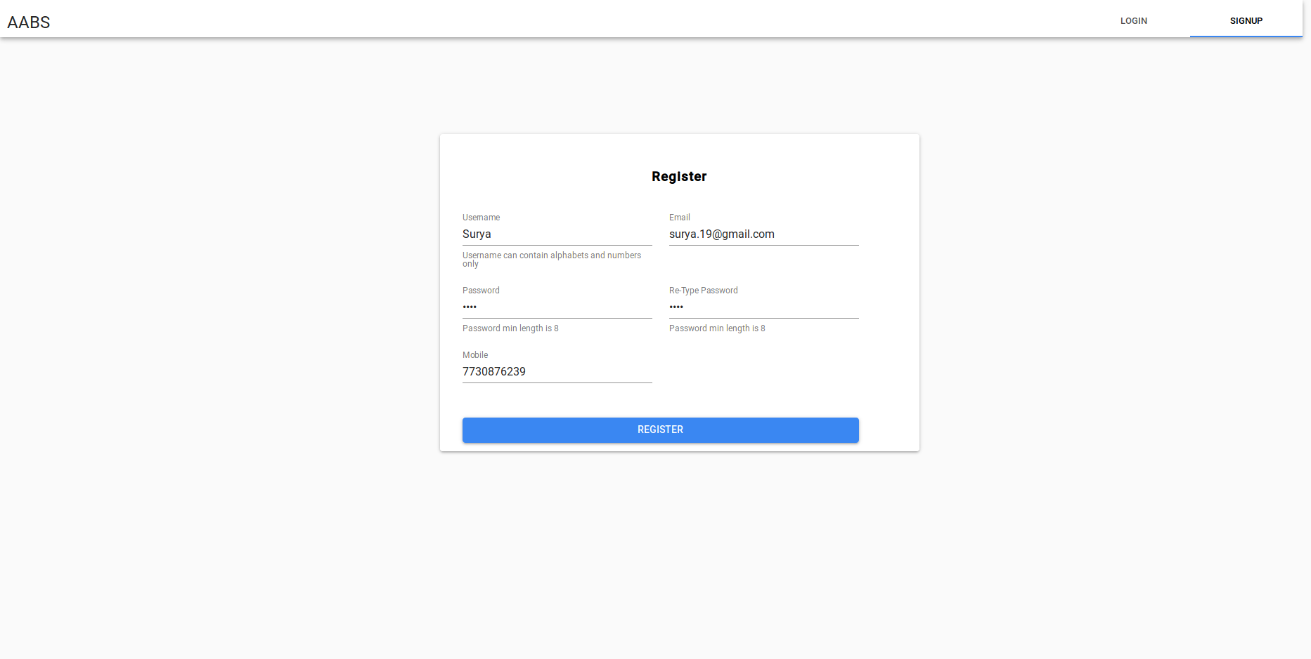

2. Update Profile.

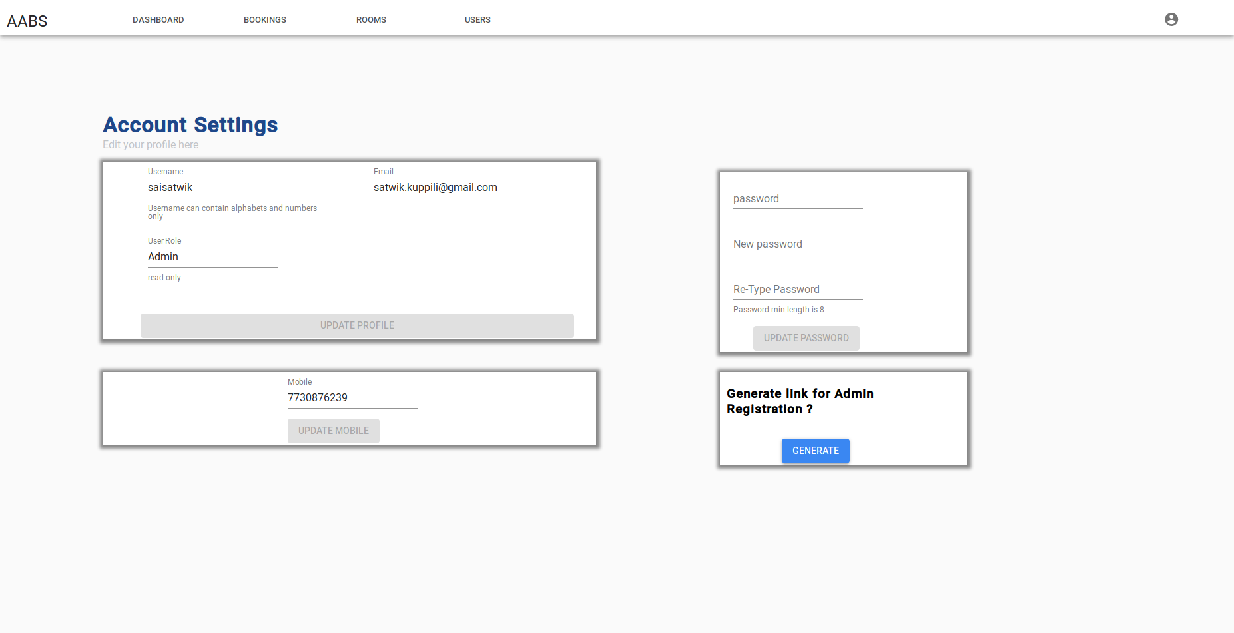

3. Check Room Availability.

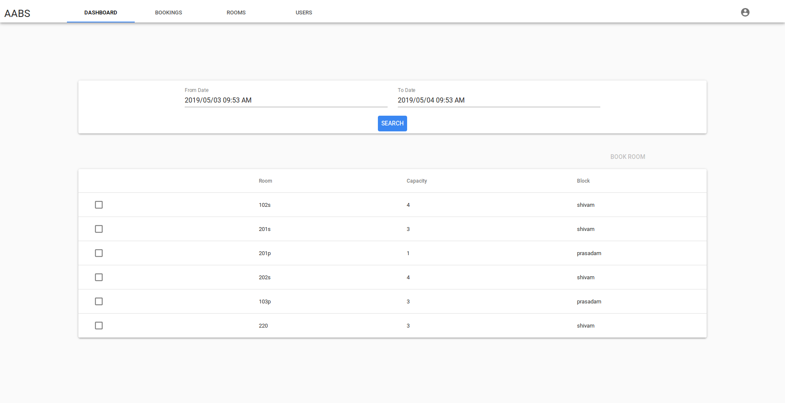

4. View Bookings.

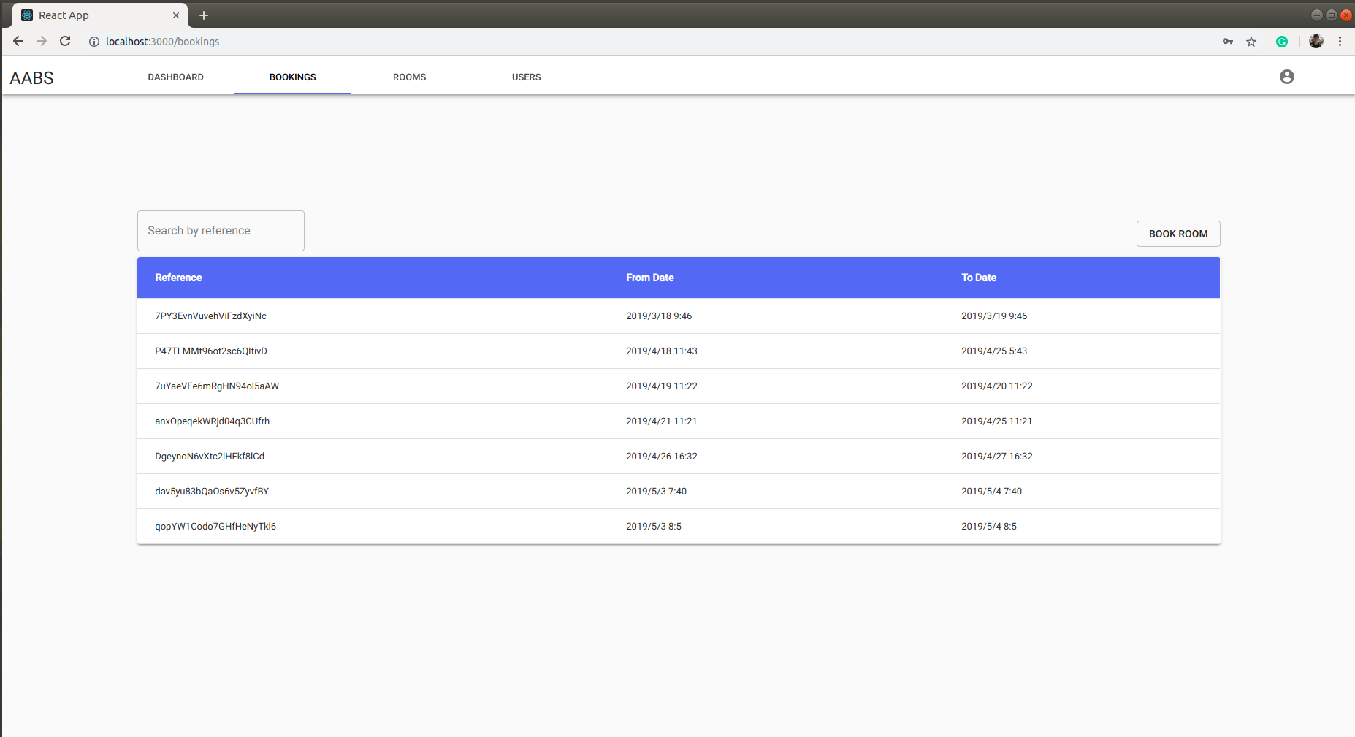

5. Cancel Booking.

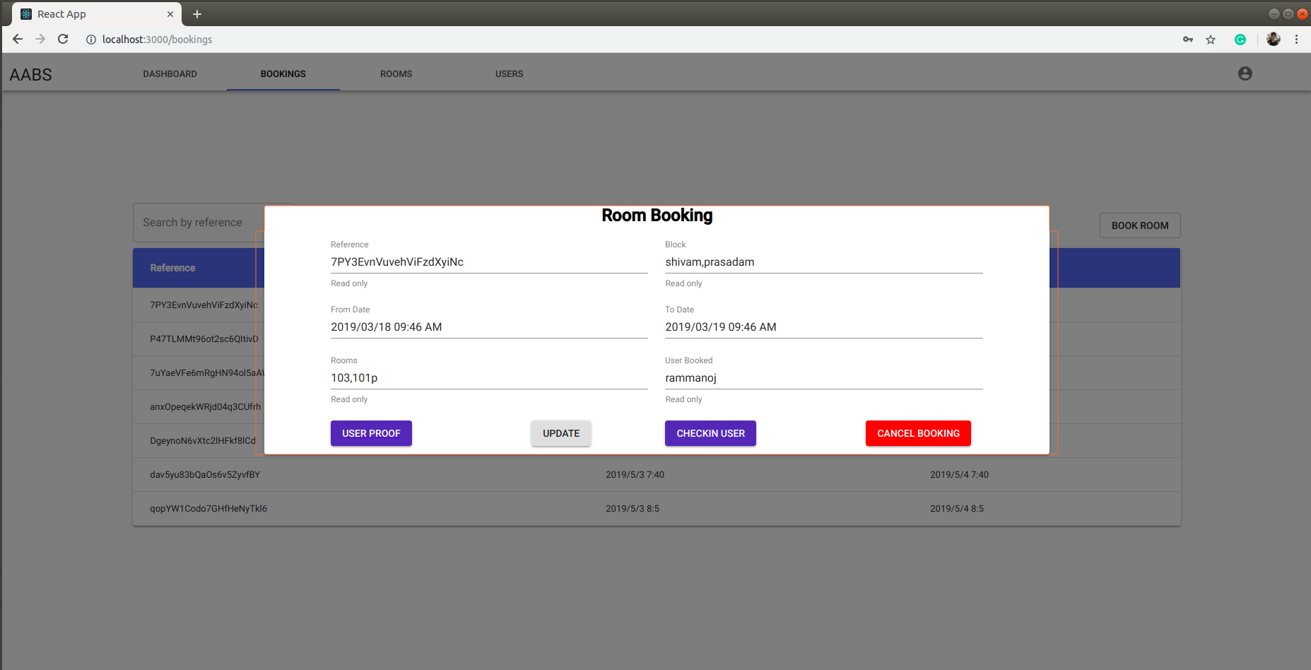

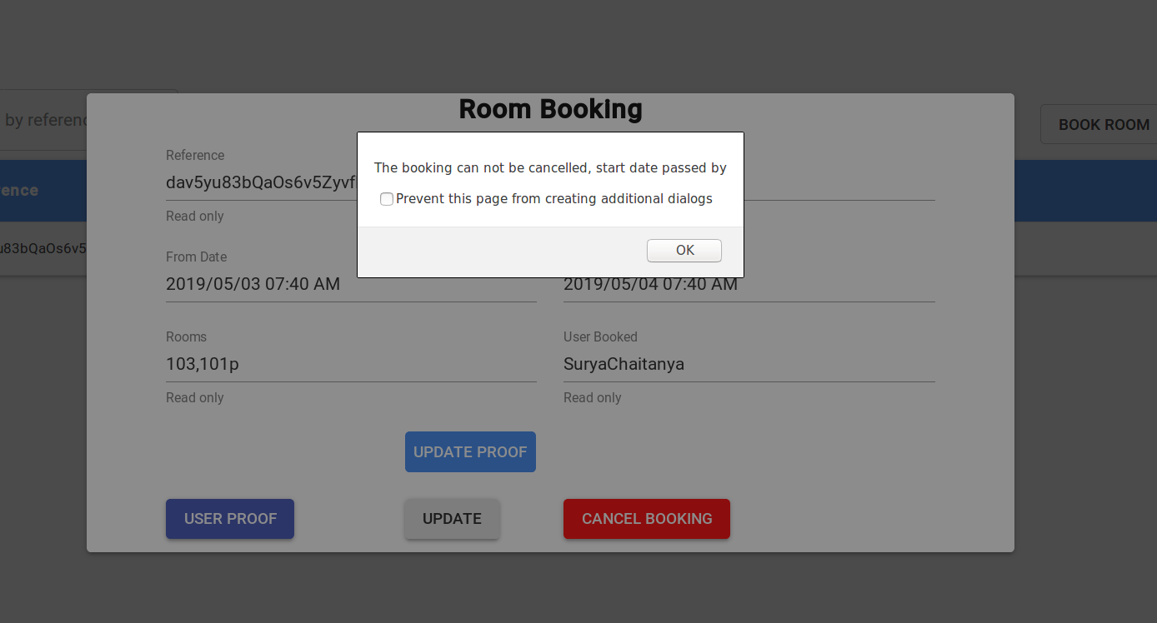

6. Admin Link Generation.

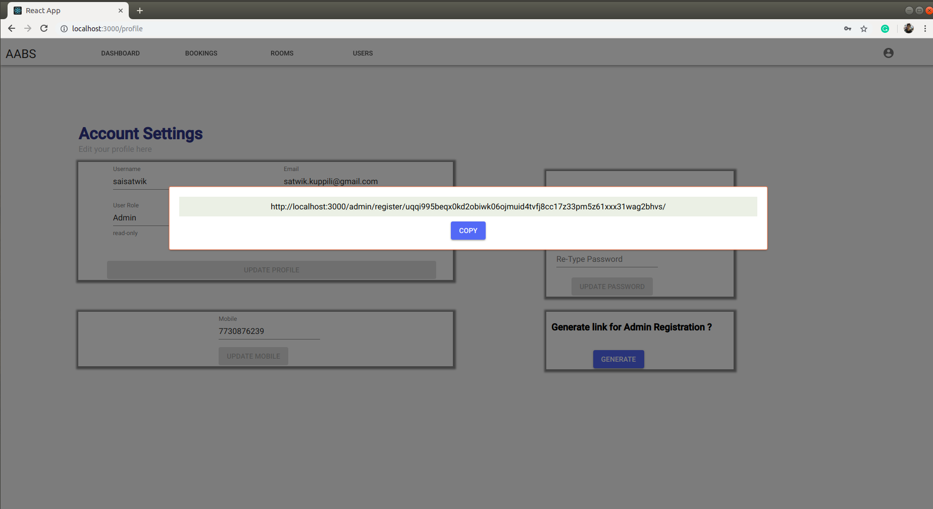

7. Remember Me.

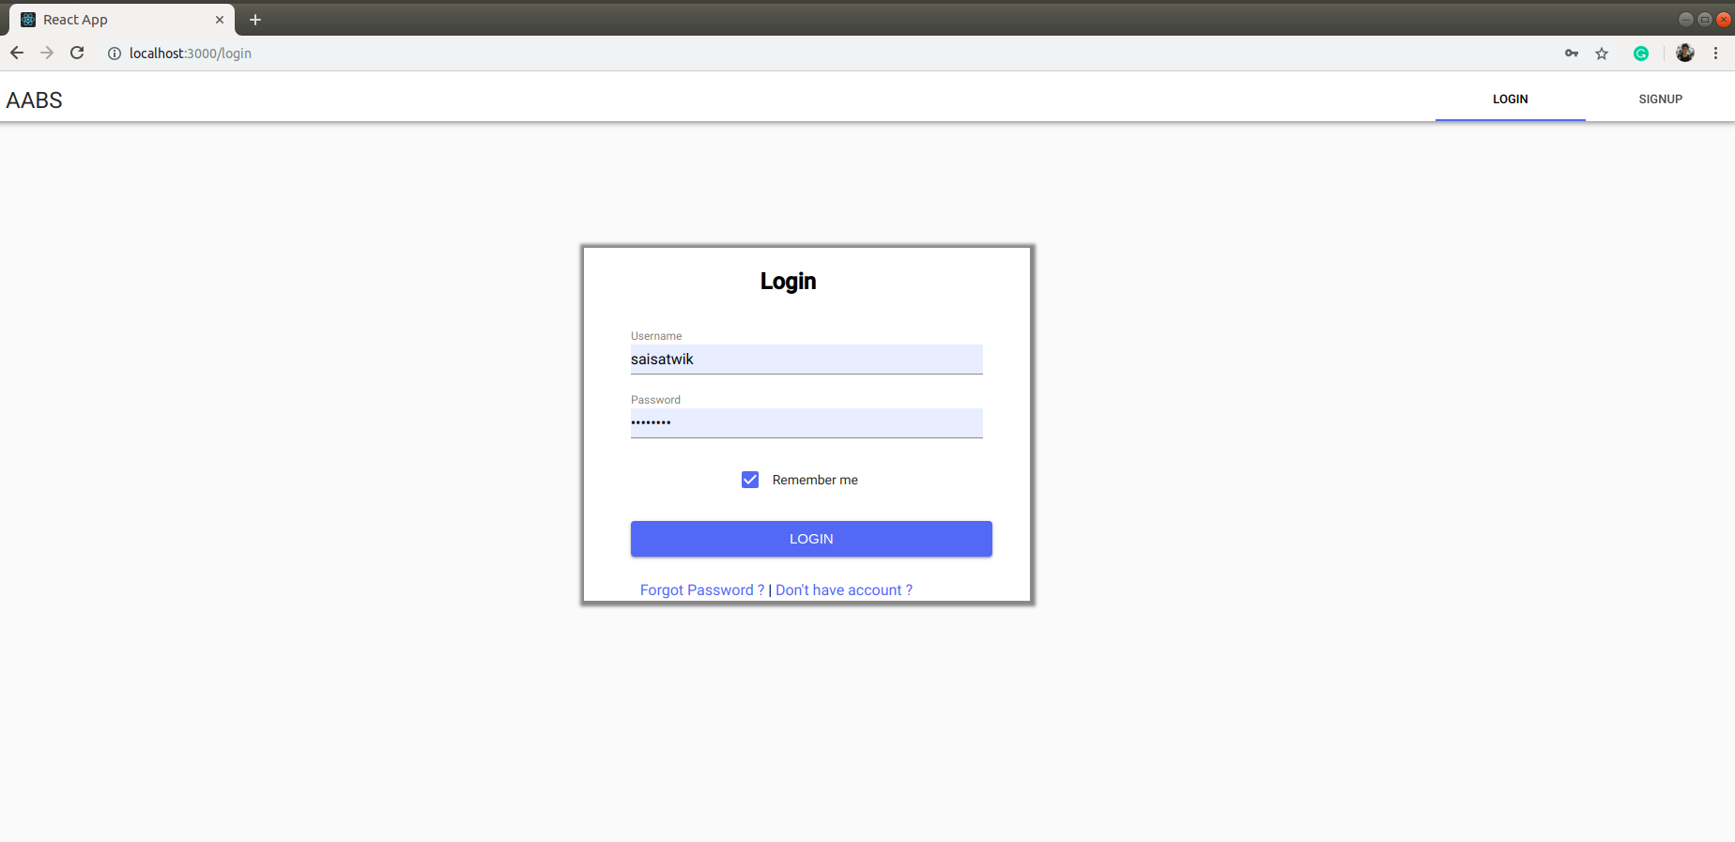

8. Add/Remove Room.

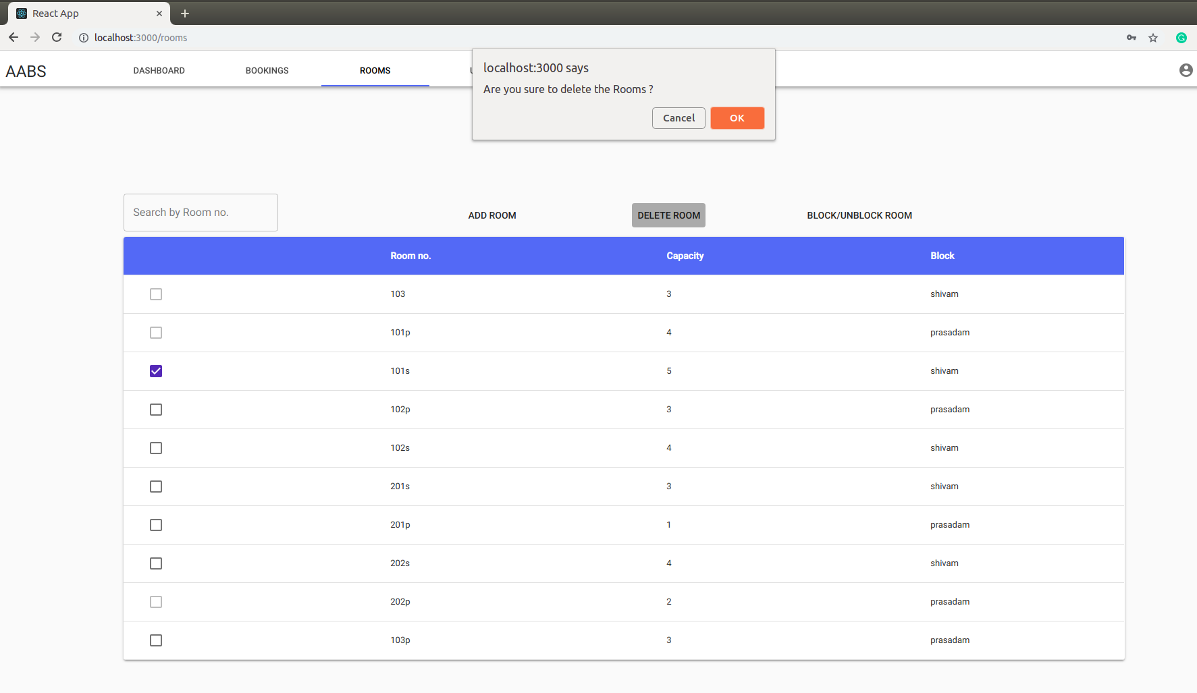

9. Remove Users.

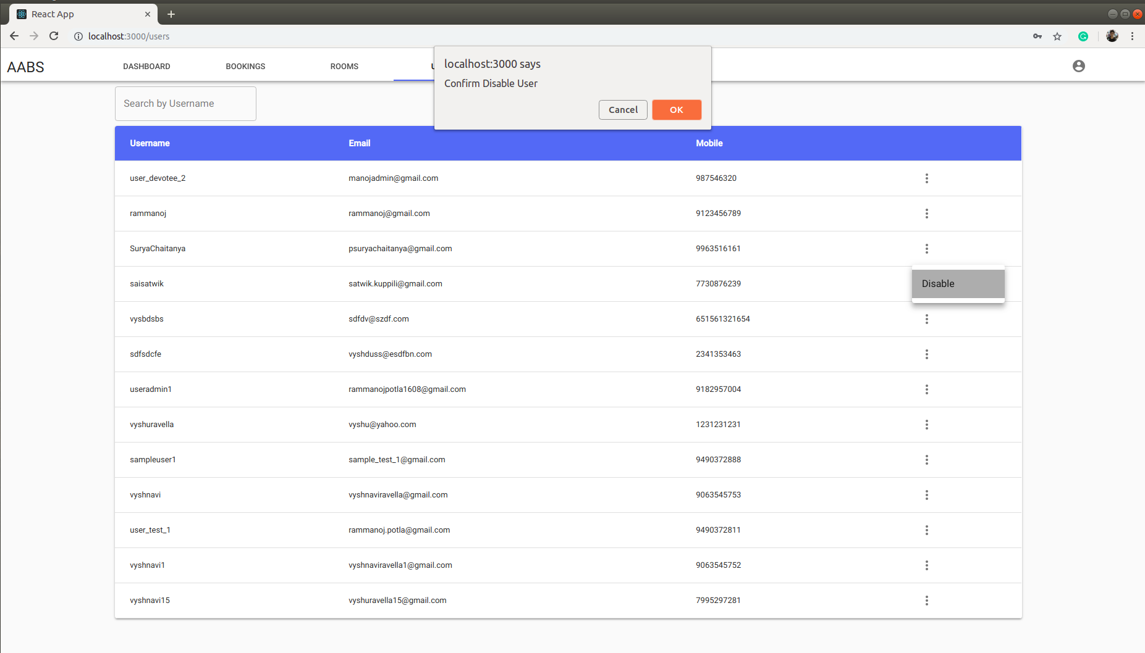

10. Update USer Proof.

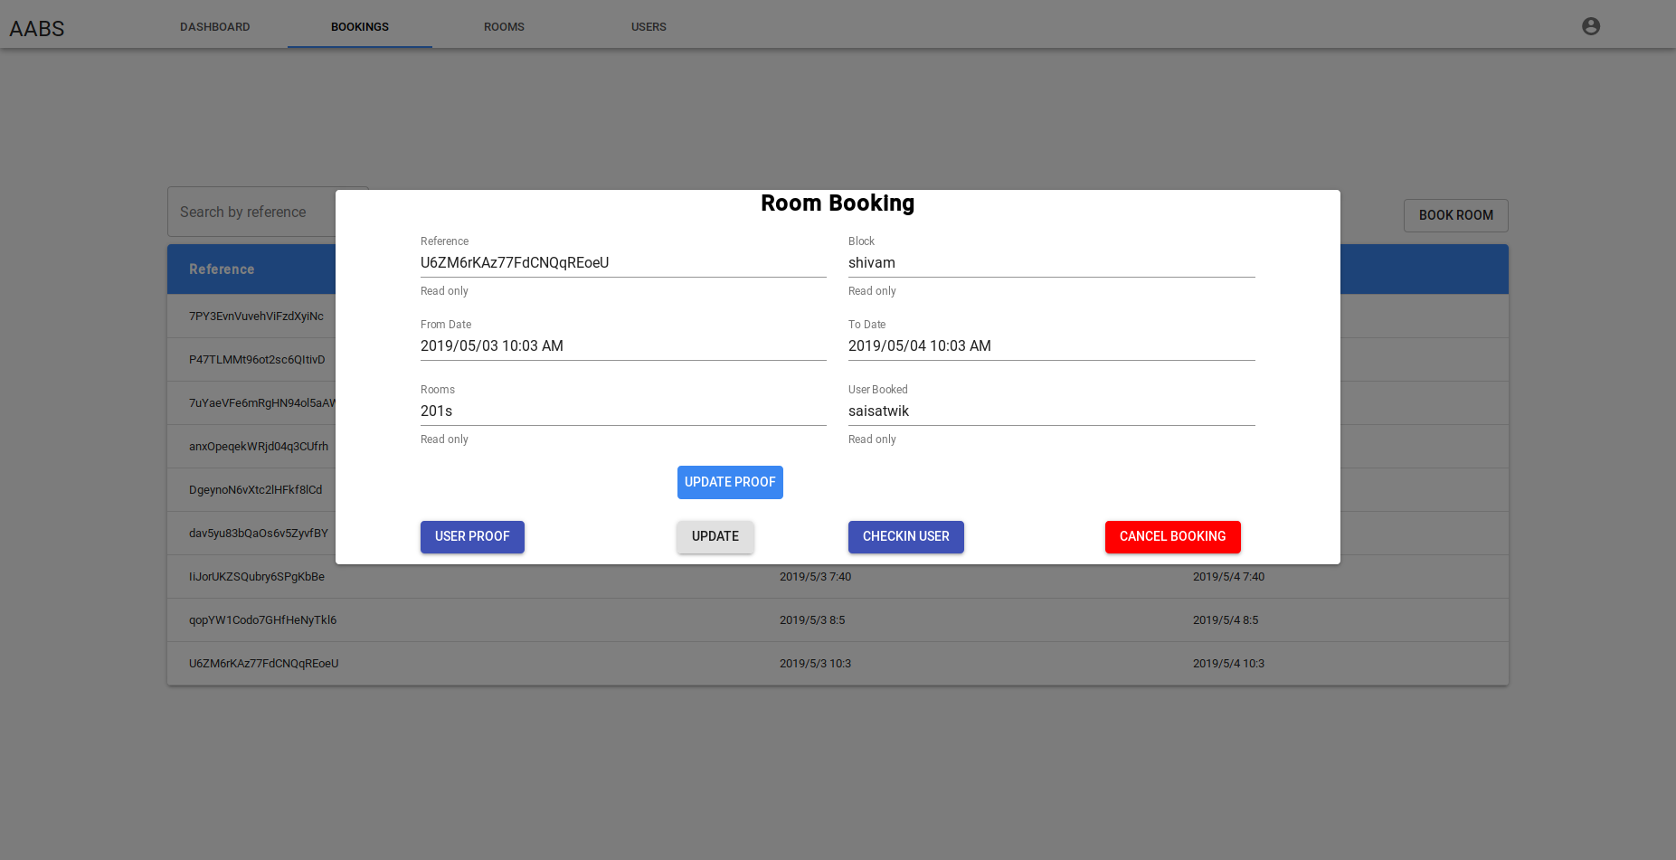

11. Checkin User.



12. Block/Unblock Room.

